

THE HERITAGE

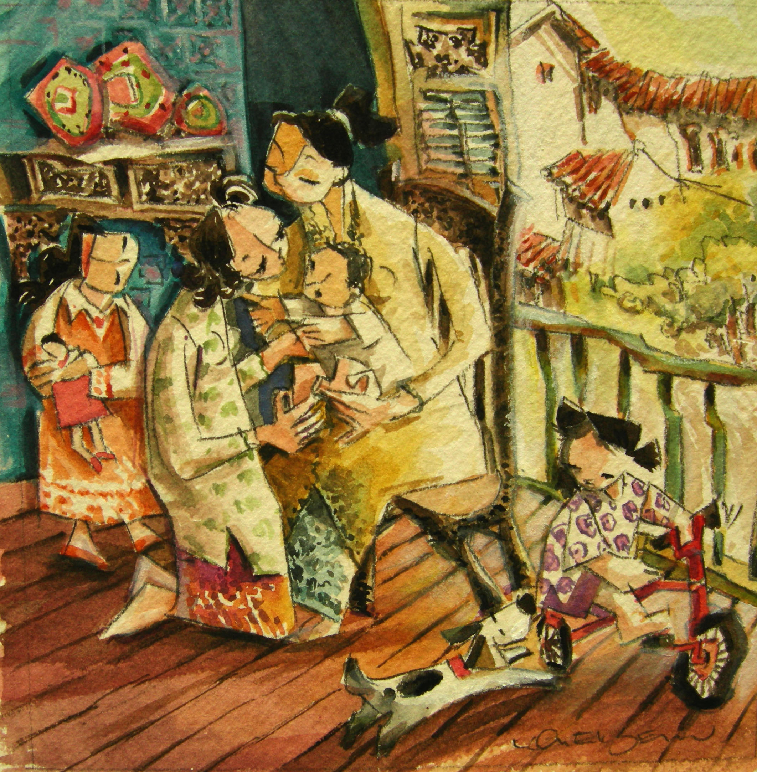
Cucu Time
A Bibi spending time with her cucu
at the beranda

